Chapter 14: Water Pollution

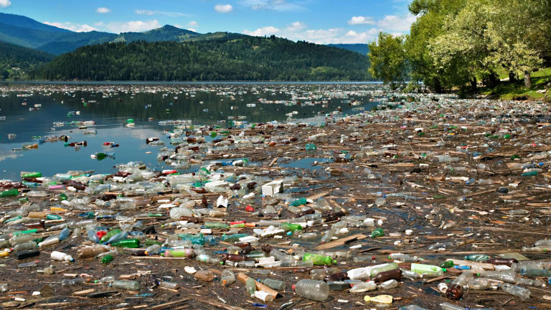

Can you….

1. Discuss the three major problems caused by wastewater pollution?
2. Explain the modern technologies used to treat wastewater?
3. Explain the sources of heavy metals and their effect on organisms?
4. Discuss the sources and effects of acid deposition and acid mine drainage?
5. Explain how synthetic organic compounds can affect aquatic life?
6. Identify the major sources of oil pollution?
7. Explain some of the current methods to remediate oil pollution?
8. Identify the major sources of solid waste pollution?
9. Explain the harmful effects of sediment pollution?
10. Discuss the sources and consequences of thermal pollution?
11. Understand the causes of noise pollution?
12. Explain how the Clean Water Act protects against water pollution?
13. Discuss the goals of the Safe Drinking Water Act?
14. Understand how water pollution legislation is changing in developing countries?